

**Project 2**

**DUGOUT- A Cricket Media App**

A Project Submitted

in Partial Fulfillment of the Requirements

for the Degree of

Bachelor of Technology

in

Computer Science and Engineering

**Under Guidance of**

Dr. Nishtha Phutela

Dr. Soharab Hossain Sheikh

Mr. Ramandeep Singh

**Department of Computer Science and Engineering**

BML Munjal University

**Title- DUGOUT**

**Declaration**

We hereby declare that the project entitled “**DUGOUT**” has been carried out for fulfilling the partial requirements for completion of the course on **Project - 2** offered in the 4th Semester of the Bachelor of Technology (B.Tech) program in the Department of Computer Science and Engineering during AY-2022-23 (even semester). This experimental work has been carried out by us and submitted to the course instructor **Dr. Nishtha Phutela, Dr. Soharab Hossain Shaikh, and Mr. Ramandeep Singh**. Due acknowledgments have been made in the project text for all other materials used. This project has been done in full compliance with the requirements and constraints of the prescribed curriculum.

**Submitted By**

|  |  |  |  |
| --- | --- | --- | --- |
| **Name** | **Section** | **Roll No.** | **Signature** |
| Khushal Rajoria (SPOC) | CSE-3 | 210C2030179 |  |
| Mridul Goyal | CSE-4 | 210C2030141 |  |
| Abhay Singla | CSE-4 | 210C2030197 |  |
| Utkarsh Singh | CSE-1 | 210C2030031 |  |
| Abhishesk Rathore | CSE-3 | 210C2030147 |  |
| Prakhar Maheshwari | CSE-3 | 210C2030173 |  |
| Arpit Joshi | CSE-3 | 210C2030160 |  |
| Tejender | CSE-4 | 210C2030158 |  |
| Aryan Kamboj | CSE-4 | 210C2030148 |  |
| Kavish Mehta | CSE-4 | 210C2030188 |  |
| Divyanshu | CSE-4 | 210C2030182 |  |

**Acknowledgement**

We would like to convey our sincere gratitude to everyone who contributed for this report and development of our project. We are grateful to the School of Engineering and Technology staff members, Dr. Soharab Hossain, Mr. Ramandeep Singh, and Dr. Nishtha Phutela, who helped us with our project. Their contribution, guidance, and experience were helpful and supportive in our achievement. They were helpful in developing our concepts, guiding our way, improving our research, and finishing our product. We appreciate the time and effort they invested. The best possible work was made achievable by their valuable feedback and perceptive suggestions.

Our team members deserve special mention since this project wouldn't have been completed without them. Other supervisors and panels deserve recognition for their advice, particularly during the project presentation, where their feedback and ideas have improved our presenting skills.

**Abstract**

The study showcases the development of a cricket media app named Dugout. Users can access match outcomes, news stories and reviews across all forms of cricket like ODI, T20 and Test matches through this application. The application applies machine learning algorithms and models with high accuracy to forecast player performances, score predictions, and win predictions for teams. The app's user interface was created using Flutter and an HCI approach was employed to satisfy the needs of its target audience.

The objective behind creating the Dugout app was to augment the user experience of cricket enthusiasts by giving them easy access to cricket-related information and analysis.This app is intended to cater for cricket fans worldwide and is user-friendly in design.The development approach of the app utilized machine learning algorithms and models to anticipate match outcomes and player performances. The HCI approach was implemented to ensure that the app's design is both navigable and intuitive for users. The app underwent evaluation based on metrics such as accuracy of predictions, user feedback and engagement. Results indicate that the app had good performance in predicting accurately and engaging users.

In conclusion, the Dugout app provides an innovative solution for cricket fans worldwide, providing them with easy access to match results, news, and analysis using machine learning algorithms and models. The HCI approach ensured that the app is user-friendly, and the evaluation results demonstrated its effectiveness in meeting the needs of its intended audience.

Result Metrics : Random forest model - Test accuracy - 86.18086 %

Score prediction: With an accuracy of 0.99, Random Forest has been performing the best for our dataset for player performance prediction.

**Table of Contents­­­­­**

**Introduction............................................................. 6**

**Motivation................................................................................ 6**

**Product: Dugout....................................................................... 6**

**1) Why is this product required?........................................ 6**

**2) Real-World Implications................................................. 7**

**Survey of Existing Solutions...................................... 7**

**Some existing apps................................................................... 8**

**System.................................................................... 11**

**System Architecture............................................................... 11**

**Features in the system...................................................................11**

**Technology Stack................................................................... 14**

**Methodology.......................................................... 14**

**Machine Learning: CRISP-DM................................................ 14**

**Human-Computer Interface: Experimental Design............... 20**

**Mobile Application Development: Features in Dugout……..23**

**Results.................................................................... 24**

**Project Management............................................. 32**

**Discussion....................................................................33**

**1.1 Introduction**

## Motivation

To cater to cricket devotees' demands for an inclusive source of information related to the sport including latest news stories, scorecards, and insights we developed the dugout application. The demand for trustworthy applications that offer precise and timely updates on cricket has increased with its surging popularity. The objective of the dugout application is to fulfill this requirement by giving users exact and inclusive information, analysis, and forecasts about cricket.

The dugout app aims to serve the necessities of cricket admirers and furnish them with a distinct and all-inclusive medium to pursue their favorite sport.

## What is the product?

The dugout app is a cricket media platform developed using Flutter, which provides users with up-to-date information and analysis related to cricket. Get access to news updates, match scores, player evaluations and team ratings for all formats of the game through this application. The Human-Computer Interaction (HCI) approach was used in its design, guaranteeing an intuitive and user-friendly interface.

The incorporation of machine learning algorithms and models within the dugout app allows for projection of player performances as well as accurate match score predictions or team win forecasts—underscoring its excitement as a platform. By employing regression models, decision trees, and random forest algorithms, the app can accurately forecast match results. Cricket enthusiasts who want to make informed decisions about their fantasy teams can find valuable insights about upcoming matches in this app.

Overall, the dugout app is a comprehensive platform for all cricket lovers, providing them with a single platform to access all their cricket-related needs.

### i. Why is this product required

The need for a like dugout is because of the increase in popularity of cricket, which has resulted in a high demand for apps that provide reliable and up-to-date real time information and analysis related to the game. Cricket enthusiasts would love a platform where they can access match results, updated news, player and team analysis, and team rankings across all formats of the game.

### ii. Real world implications?

The cricket industry as a whole and cricket fans could experience several real-world implications due to Dugout.

1. With Dugout, cricket enthusiasts can conveniently obtain information regarding match results, news, player rankings and analysis in all cricket formats. Staying abreast of all the recent cricket developments is a breeze thanks to this one-stop source that eliminates the need to scour different platforms for updates.
2. Better decision-making: The app's prediction models, including player performance, score predictions, and win predictions of teams, can assist cricket fans and industry professionals in making informed decisions. For instance, fans can use this information to make better fantasy cricket team selections or bet on matches more effectively.
3. Industry insights: The data generated from the app's usage can be analyzed to provide valuable insights into user behavior, preferences, and trends in the cricket industry. This can be useful for stakeholders such as sports marketers, advertisers, and cricket boards to make better decisions and improve their offerings.

**1.2 Survey of existing solutions**

**ESPNcricinfo -**Cricket news, scores, and analysis are available in abundance on ESPNcricinfo. The app employs various datasets, comprising live scorecards, player and team statistics, as well as historical archives. Various sources are employed to gather the information, including both online databases and live matches. The application offers real-time score updates, commentary on each ball, and articles with news. The app's usability and user experience were assessed through user testing and feedback. This app has some drawbacks, including possible errors in its information and restrictions on obtaining high-quality information about certain matches or events.

**Cricbuzz -** Cricbuzz is yet another well-known application that provides live scores, commentary, and news updates for cricket matches taking place worldwide. The app uses a dataset that is alike ESPNcricinfo which involves player statistics as well as live scorecards. Numerous sources like live matches and online databases are used to accumulate the data. From player stats to team rankings and match schedules—this app has it all. By utilizing user testing and feedback, evaluations for both usability and user experience were conducted. Potential inaccuracies in the data and limitations in its availability/quality for specific matches/events are among the app's limitations.

**The official ICC app -** The official ICC app is the official app of the International Cricket Council (ICC), and provides live scores, news updates, and highlights from international cricket matches. The app uses a similar dataset to other cricket information related apps, including live match data and historical archives. The data is collected from a range of sources, including live matches and online databases. The app provides live score updates, news articles, and highlights. Usability and user experience evaluations have been conducted through user testing and feedback. Limitations of the app include potential inaccuracies in the data and limitations in the availability and quality of data for certain matches or events.

|  |  |  |  |  |
| --- | --- | --- | --- | --- |
| App Name | Dataset used | Methodology | Limitations | Google Play Store Rating |
| ESPNcricinfo | Live scorecards, player and team statistics, historical archives | Machine learning algorithms trained on ball-by-ball data | Potential inaccuracies in the data, limitations in availability and quality of data for certain matches or events | 4.5 (1,098,276 ratings) |
| Cricbuzz | Live scorecards, player statistics | Live updates and analysis | Potential inaccuracies in the data, limitations in availability and quality of data for certain matches or events | 4.4 (4,297,014 ratings) |
| Official ICC app | Live match data, historical archives | Live scores, news updates, and highlights | Potential inaccuracies in the data, limitations in availability and quality of data for certain matches or events | 3.9 (58,989 ratings) |
| Cricket Exchange | Live match data, player statistics | Live updates and analysis | Potential inaccuracies in the data, limitations in availability and quality of data for certain matches or events | 4.4 (426,751 ratings) |
| Cricsmith | Live match data, player statistics | Live updates and analysis, live polls and quizzes | Potential inaccuracies in the data, limitations in availability and quality of data for certain matches or events | 4.3 (6,585 ratings) |

**2. System**

# System Architecture

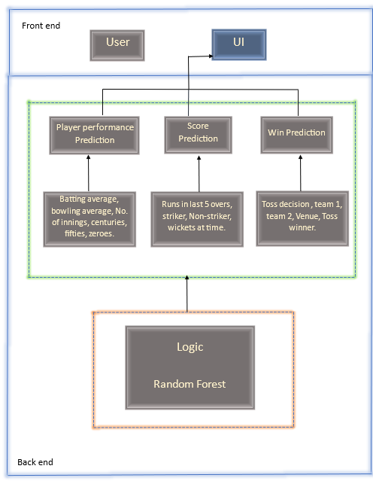

Features in the system:

|  |  |  |  |
| --- | --- | --- | --- |
| S. No | Feature | Design Principle | Significance of the feature |
| 1. | Home Page Tabs | Visibility | It presents information in a way that is easy to understand and navigate. By following this principle, we provide a user-friendly and intuitive interface that cricket fans can use to explore and enjoy all the features and sections of the app. |
| 2. | Teams | Visibility, Signifier | The teams page is designed with a focus on presenting the relevant information about each team in a way that is easy to understand and engage with. Presented with all details related to a team. |
| 3. | Schedule | Visibility | The schedules page is designed in a way that allows users to easily browse through different matches and teams, using clear and intuitive navigation and search functionality. This could include the use of filters, sorting options, and other design elements that make it easy for users to find the matches they're interested in. |
| 4. | Venue | Visibility, signifier | To achieve good visual design, the venue page is designed with a clear layout that presents the information in a logical and organized manner. The use of typography, color, and imagery is consistent with the overall design of the app, and is used to create a visual hierarchy that guides the user's attention to the most important information. |
| 5. | Point Table | Visibility | Designed with a focus on presenting the player or team rankings in a clear and structured manner, making it easy for users to find the information they are looking for. |
| 6. | Rankings | Visibility | Designed with a focus on presenting the player or team rankings in a clear and structured manner, making it easy for users to find the information they are looking for. |
| 7. | History | Visibility | It helps in finding and presenting relevant information to users. In the case of the history page, the goal is to present details of matches that have already happened in a way that is easy to find, understand, and navigate. |

Technology Stack

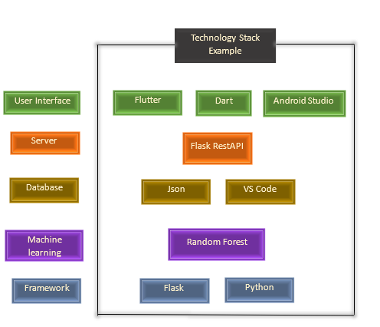

**3. Methodology**

# ML (CRISP-DM)

Business Understanding

The sports sector produces an enormous volume of data that includes match outcomes, player particulars, team statistics and commentary accounts. This data's volume, variety, and complexity make extracting meaningful insights from it a challenge. The sports industry can make informed decisions using Dugout, a data analytics project. It provides insights into players' performance and team strategy through data analysis.

A comprehensive view of players' performance and team strategy based on data analysis is what they aim to deliver to the sports industry. A solution to a business problem is being sought by Dugout

· What are the performances of various players and teams in diverse situations and against distinct opponents like?

· Which factors affect both player and team performance the most?

· Teams looking to win more often may benefit from optimizing their strategy using data analysis. How is this accomplished?

Dugout provides sports analysts and managers with valuable insights based on thorough data analysis, allowing for informed decision-making. By way of explanation, insights can involve detecting players who are excelling greatly and proposing that they receive increased playing opportunities. Additionally, spotting weaknesses within a squad which require strengthening or even putting forward recommendations regarding changes in strategic approach by analyzing previous performance records.

Data Understanding

To gather its insights and knowledge base the Dugout project relies on multiple forms of raw material including match stats camp; figures as well as player profiles alongside team overviews camp; expert opinions. Diverse sources are used to collect data, such as APIs and web scraping.

● Match data: This includes data about each cricket match, such as the date, location, teams, score, and match events.

● Player data: This includes data about each cricket player, such as their name, age, nationality, position, and statistics such as runs scored, wickets taken, and batting/bowling averages.

● Team data: This includes data about each cricket team, such as their name, country, league, and statistics such as the number of wins, losses, and draws.

Data Exploration:

To understand its structure, quality, and relevance to a particular business problem during the stage of comprehending data, the Dugout Team explores through it. Some of the key steps in data exploration are:

● Data profiling: This involves examining the data to understand its structure, such as the number of records, columns, and data types.

● Data quality assessment: This involves identifying any data quality issues, such as missing values, duplicates, and outliers.

● Data relevance assessment: This involves determining the relevance of the data to the business problem and identifying any gaps or limitations in the data.

Data Preprocessing:

After exploring the data, The Dugout team preprocesses the data for analysis after exploring it. Some of the key steps in data preprocessing are:

● Data cleaning: This requires managing all problems related to data quality, such as absent values, copies, and anomalies. Here are some specific steps taken by the DugOut team-

Missing data: We filled in appropriate values when there is missing data. For numerical data, the median value is utilized whereas categorical data employs the mode value.

Duplicates: Eliminating any duplicate records from the dataset helps the team avoid biased analysis.

Outliers: The team manages to identify and handle any outlier present in the data. If there are doubts about the accuracy of scoring, especially when players score unexpected amounts of runs, teams investigate possible mistakes made during data entry. Ensuring data accuracy and game fairness is aided by this.

● Data transformation: Making data appropriate for analysis often involves transforming it. This might include converting categorical variables to numeric values or normalizing numeric values.

Label encoding: To convert categorical data like player positions and match venues into numeric values, one technique is called label encoding. The variable's categories are labeled with unique integers. The dataset becomes easier to work with when its feature count is reduced.

Normalization: A common scale between 0 and 1 is used to normalize numerical variables, including player scores. The accuracy of comparing and analyzing data is improved with this.

Data aggregation: Multiple sources are merged and summarized to offer an all-inclusive perspective on the data. One way to gain insight into a particular match or player is by combining data on match schedules, player statistics.

● Feature engineering: Creating new features is done by analyzing the available data, like determining the average number of runs scored per match for each player or team.

Player rankings: The team produces player rankings by evaluating their performance in previous matches. By comparing players, users can predict their performance in upcoming matches.

MODELING:

Model Selection:

o Score Prediction: Linear Regression and Random Forest were used as the two machine learning models for predicting scores. Random Forest showed greater accuracy with a score of 91%, compared to Linear Regression which scored an accuracy rate of just 89%, as determined by the team upon evaluating both models' performances. Consequently, our choice for score prediction was the Random Forest model.

o Win Prediction: We applied four machine learning models (Logistic Regression, Decision Tree Classifier, Support Vector Machine and Random Forest) to forecast the winner. The team discovered that Random Forest had the highest accuracy of 57% after evaluating each model's performance. Hence, the model selected for win prediction was Random Forest.

o Player Performance Analysis: Naive Bayes, Decision Tree and Random Forest were among the three machine learning models that we applied to analyze player performance. The highest accuracy rate among all models evaluated was achieved by Random Forest at an impressive 99%, as determined by the team's evaluation. The selected model for analyzing player performance is Random Forest.

Training and Testing Data:

For every task, the team created training and testing datasets by dividing their prepared data. Training data was employed for training the machine learning models, whereas testing data was used for assessing their performance.

Model Training:

The process of training machine learning models involved utilizing the training dataset and applying selected algorithms. The model's accuracy and generalization were enhanced by using various techniques like bagging, boosting, and stacking.

Hyperparameter Tuning:

We optimized model performance by tuning hyperparameters using grid CV search. The team could improve both accuracy and generalization levels in their models through systematic hyperparameter adjustments coupled with performance evaluations.

Model Evaluation:

Once we completed training and tuning, we evaluated model performance using the testing dataset. They evaluated the models by using different performance metrics which included accuracy, precision, recall, F1 score .The team ensured that their models did not overfit the training data by utilizing cross-validation techniques.

Model Deployment:

The Dugout app received the trained and optimized models from the team. To obtain predictions on cricket match outcomes, total runs scored by teams or player performance analysis; Users can interact with the model.

Monitoring:

To guarantee the models' performance over time, we put into practice various monitoring strategies.

Data Drift Detection:

Continuous comparison between the distribution of input and training datasets is how we monitor for potential instances of data drift. The team would update and verify the accuracy of the model by retraining it with fresh data if there were a noticeable difference in the distribution of data.

Performance Metrics Tracking:

Closely monitoring accuracy, precision, recall and F1 score helped us achieve satisfactory results with their models. Visualizing the plotted metrics over time helped them spot any trends or anomalies.

Model Retraining:

We regularly monitored the models' performance and retrained them as necessary to enhance their performance. Retraining the models using automated scripts enabled seamless deployment of new ones.

# HCI (Experiment Design)

An HCI method was employed in designing our app as a solution to the usability and UX/UI issues identified through user feedback.

1. User feedback collection: User feedback was obtained through surveys, user interviews, and usability testing. Our analysis revealed the most common usability and UX/UI challenges experienced by our users.

2. Problem prioritization: Our approach to problem prioritization involved assessing each problem's severity and impact on user experience.

3. Solution ideation: Taking into account the user’s feedback, we brainstormed a few solutions to address the identified problems.

4. Solution implementation: To improve our users' experience we implemented several changes such as enhancing themes and colors in addition to adding new sports categories with improved feedback features. We also added transitional effects between pages while updating actions notifier's size for better visibility. Thoroughly testing the app was a priority before we released the updated version.

5. Conducting usability testing helped us determine how effective the implemented solutions were and highlight any remaining usability issues.

6. Using iterative design, we made further improvements to the app to enhance its usability and user experience by incorporating feedback received from usability testing.

With time, we'll continue to better the app by acting on user feedback and refining its design to enhance the overall user experience. By utilizing an HCI approach when designing apps, products become more effective and user-friendly by keeping users' needs and preferences in mind.

Further, we have used following qualitative parameters for testing:

**Learnability –**

1. Our app's features can be effectively utilized by following its clear and concise instructions. In addition, pop-ups show up when a user first opens the app, explaining how to utilize its features.

2. Familiar design patterns are used in our app, which users are already accustomed to. Commonly used icons, buttons, and menus found in other apps are utilized.

3. The design of our app prioritizes simplicity and ease of use. Achieving a clean and uncluttered interface requires reducing clutter.

4. Test with real users: Our app is to be tested with real users to ensure that it is easy to use and meets their requirements. This involves conducting surveys using google forms and other testing sessions or collecting feedback.

**Memorability –**

1. Consistent design : The consistency of our app's design has been ensured, with a clear and predictable visual hierarchy maintained throughout. Where certain features can be found and how to navigate through the app is explained to assist users in remembering it.

2. Simple and clear language: Our application employs simple and comprehensible language, enabling users to easily retain its usage instructions.

3. Clear navigation: Users will have no problem finding the functions they need as our app has a clear and intuitive navigation system. We facilitated user recall by utilizing easily comprehensible labels that are descriptive, as well as standardized icons and symbols.

4.Simplified Interfaces : The simplicity of our app's interface comes from displaying only necessary features and information. To help users better recall how to navigate the app, reducing cognitive load is important.

**Error correction –**

1. User input Validation : User input validation is a significant defensive technique against errors. We check for correctness and proper formatting by validating user input at every point in our app. This helps in avoiding mistakes such as wrong scores or player details.

2. Monitoring: Our app will be under constant surveillance for timely detection and resolution of errors. One can track app performance, user behavior, and other metrics by implementing monitoring tools.

3. Testing : Conducting thorough tests on the app is crucial to guarantee its error-free performance.

4. Updates: Frequent updates to the application could help prevent any issues from arising as time passes. The app's functionality should be improved and bugs fixed promptly when updates are rolled out.

**Satisfaction –**

1. Ease of use : Using our software is easy. Users can enhance their overall satisfaction by effortlessly searching for their preferred teams and players.

2. System performance : Users are highly likely to feel satisfied with our app's performance since it operates efficiently and responds rapidly.

3. User interface design : A well-designed user interface is present in our system. Additionally, finding your desired team or athlete is effortless since we present their respective country's flag and photograph. Our aim is to satisfy users by displaying images for each feature, which eliminates any potential misunderstandings about its function.

4. User expectation : Our system meets all user expectations by providing the latest news and matches, which increases satisfaction.

**Utility –**

#### 1.We have prioritized user satisfaction when designing our app. Understanding the target audience's needs and preferences is crucial in designing the app accordingly. By providing intuitive menus and clear instructions, our app becomes easy to navigate.

#### 2. By catering to individual interests, our app provides customized and pertinent content. This encompasses live scores, news updates, player profiles, and highlights of earlier games.

#### 3. To inform users about significant occurrences such as match updates, breaking news, and score changes; it is recommended to utilize push notifications. The app keeps users engaged even when they are not actively using it by implementing this functionality.

Mobile App Development (AppDev)

The app's user interface and experience were designed using Flutter widgets, particularly List View. The majority of pages use builder and stateful widgets.

The data was loaded by us into the app through JSON files, which were subsequently parsed utilizing Flutter's inbuilt JSON decoder.

By means of Flask and REST API, we integrated the machine learning model in the app. Real-time access to model predictions became possible for the app due to this integration, which allowed them to be shown to users.

By utilizing asynchronous functions, we were able to create engaging user experiences through animations like hero animations.

We performed tests on different devices and emulators to guarantee the app's compatibility and stability. To identify and fix any errors in the app, we also utilized debugging tools.

The app was deployed to the app store and other relevant platforms after undergoing full development and testing. It became accessible to the users.

A user-friendly and engaging app was created by using Flutter widgets, asynchronous functions, as well as integrating machine learning models with Flask and REST API. Additionally, the application offers sophisticated functionalities such as instantaneous forecasts. Ensuring that the app was stable and functional, involved continuous testing and debugging in the iterative development process. By and large, the process assisted us in constructing a superior application with a fantastic user experience.

**4. Result**

UI Screenshots

ODI Rankings Page

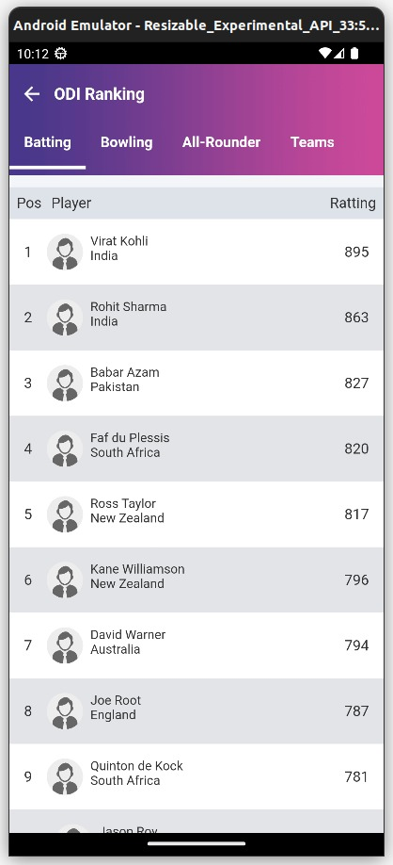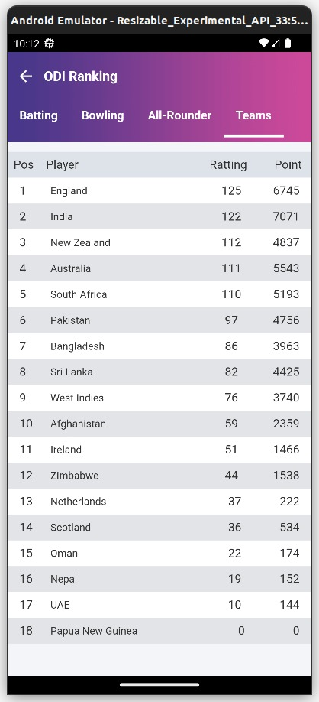

Home Page Summary Page Scorecard

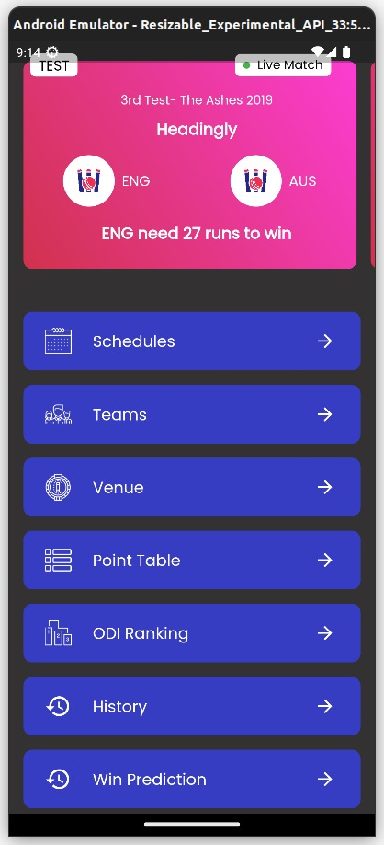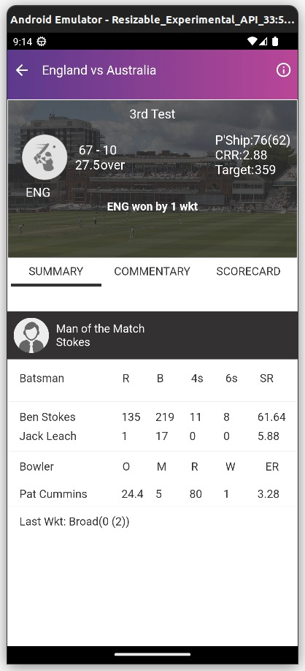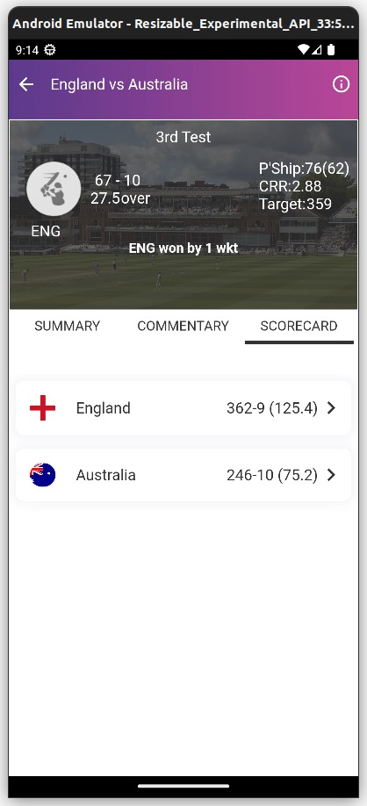

Schedule Page Teams Page Venue Page

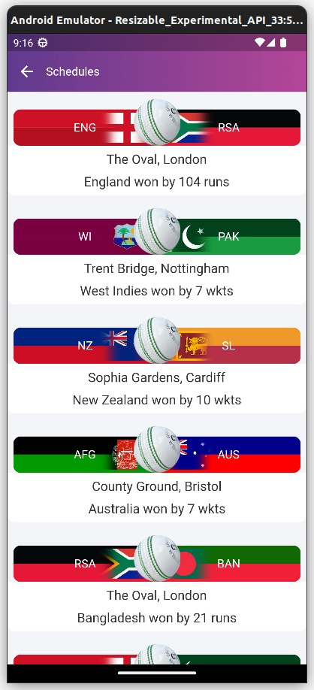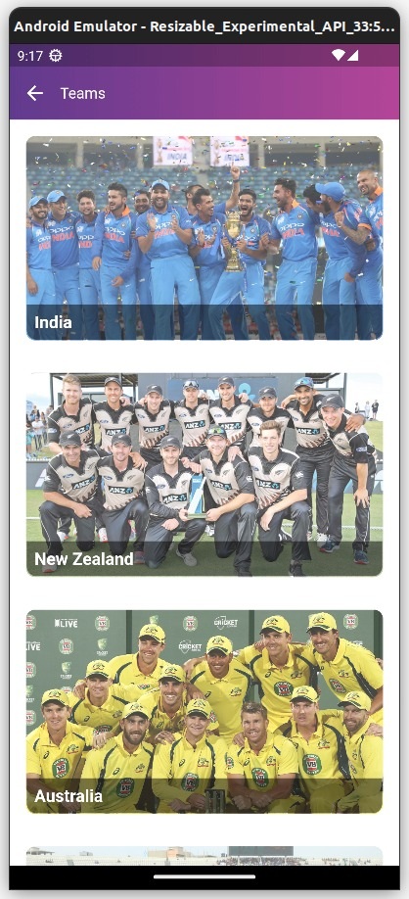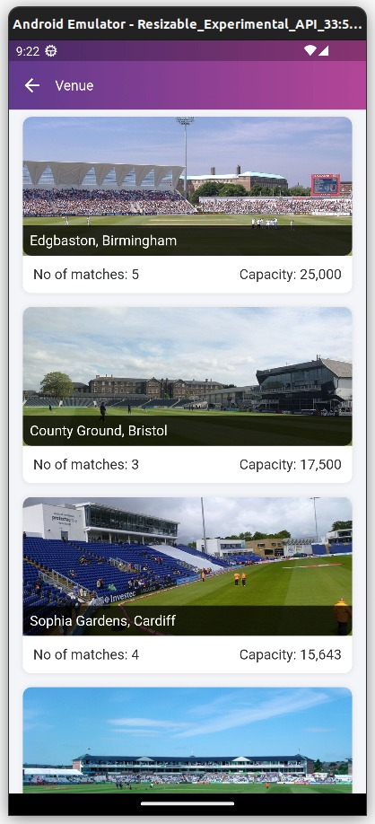

Win Prediction Team Score

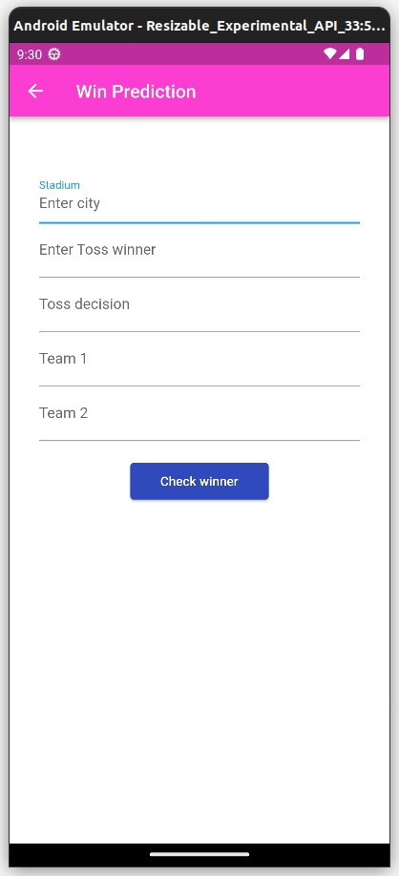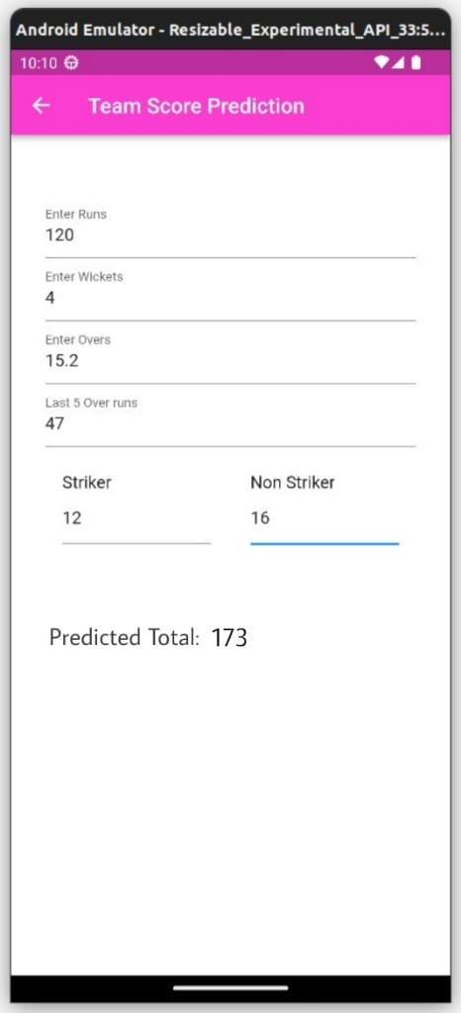

ML Results

1. Player Performance prediction model

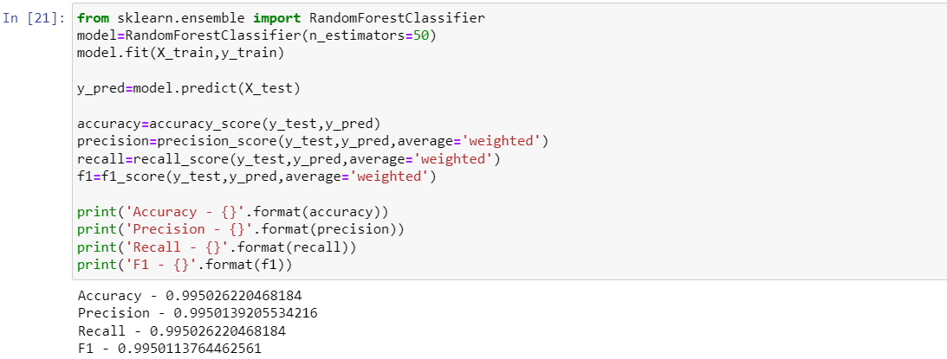

1. Win Prediction model

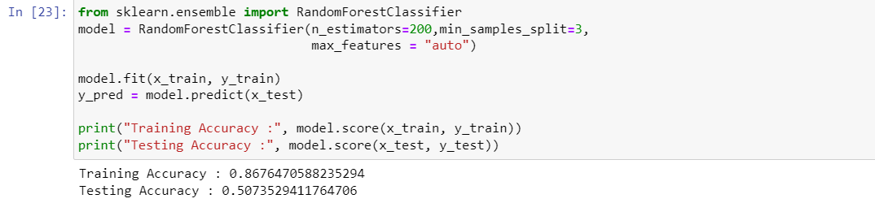

1. Score Prediction model

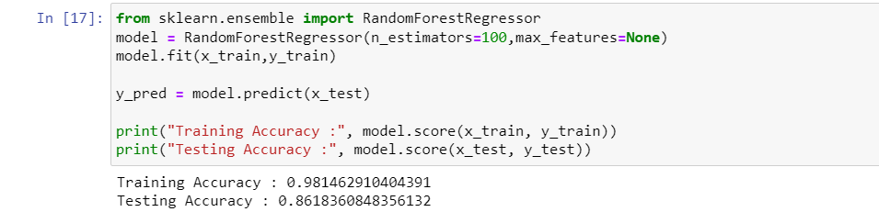

User Evaluation Result

We gave our users a Google form with a few questions in order to receive valuable

feedback:

1) How's the overall app layout?

2) Do you like the color scheme?

3) Did you find our app informative for sports news?

4) Did you find any missing features in the app that you find should be

incorporated?

5) Did you face any technical issues or bugs while using the app?

6) On a scale of 1-5 how well did our app perform in terms of speed and

responsiveness?

7) How would you rate the overall user experience?

8) Is there anything that can be improved about our app? Please provide your

Suggestions.

User’s Feedbacks based on their answers:

We received plenty of user feedback, and the following were the most common usability and

UX/UI problems:

● Make some improvements in theme.

● Color schemes can be better.

● Include other sports as well.

● Add more feedback features.

● Add transitions between pages.

● Action notifiers and icon sizes weren't great.

User Testing

We gave a test user one task to try our app and do win prediction for his favorite team.

Time it took the user to perform the task: 44 seconds.

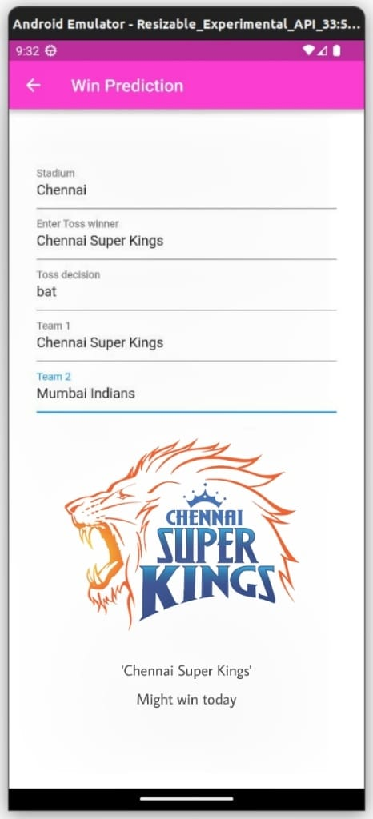

**5. Project Management**

# **5.1 Gantt Chart**

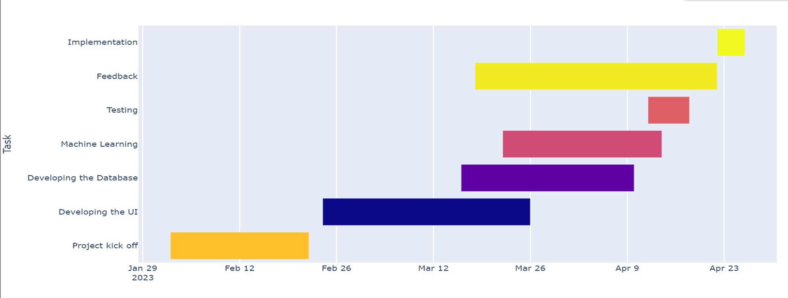

**5.2 Course Progress**

Iteration 1:

* Project kick-off: Started on February 2, 2023, and finished on February 22, 2023. During this time, the project was conceptualized, and the team was assembled.
* Developing the UI: Started on February 24, 2023, and finished on March 26, 2023. In this iteration, the team focused on designing the user interface and user experience of the app.

Iteration 2:

* Developing the Database: Started on March 16, 2023, and finished on April 10, 2023. In this iteration, the team developed the database and incorporated it into the app.
* Machine Learning: Started on March 22, 2023, and finished on April 14, 2023. The team worked on developing and integrating machine learning models into the app.

Iteration 3:

* Testing: Started on April 12, 2023, and finished on April 18, 2023. In this iteration, the team tested the app thoroughly to ensure its compatibility and stability.
* Feedback: Started on March 18, 2023, and finished on April 22, 2023. The team collected user feedback and incorporated it into the app's design and functionality.
* Implementation: Started on April 22, 2023, and finished on April 26, 2023. The app was implemented, and final touch-ups were made before launching it on the app store and other platforms.

**5.3 Distribution of Tasks**

Tasks were divided as following:

Flutter Front End: Abhishek Rathore, Khushal Rajoria, Arpit Joshi, Utkarsh Singh

Back End: Abhishek Rathore, Khushal Rajoria, Arpit Joshi

Machine Learning: Mridul Goyal, Abhay Singla, Aryan Kamboj

Feedback and User Testing: Prakhar Maheshwari, Divyanshu, Utkarsh Singh

Report and Compiling: Tejender and Kavish Mehta

**5.4 Peer to Peer Evaluation**

Here is the possible breakdown of grades for each member of the group.

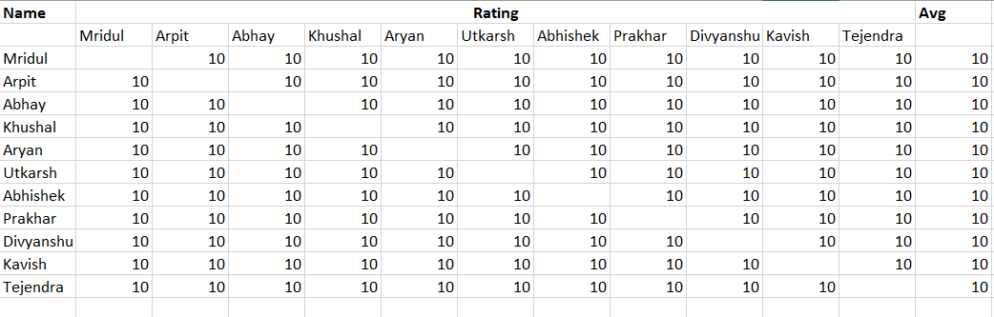

# **6. Discussion**

Easy access to match results, news, rankings, and analysis across all formats of the game was our goal in developing the Dugout app for cricket enthusiasts. Generating accurate and timely information involves utilizing machine learning algorithms and models, with the app's UI being developed using Flutter. To satisfy our intended users, we employed a Human-Computer Interaction (HCI) strategy that involved incorporating user feedback and conducting tests during the development period.

**Key Learnings:**

Through the development of Dugout, our team gained valuable experience in machine learning, UI design, and user testing. We learned that designing an app that meets the needs of a specific user group requires constant communication and feedback from the target audience. We also gained insight into the challenges of working with large datasets and the importance of developing algorithms that can handle data inaccuracies and inconsistencies.Further we learned teamwork skills and working under deadlines and pressure.

**Limitations:**

The Dugout app's limitations include possible inaccuracies in its data. Although we tried our best to guarantee that the machine learning algorithms and models were trained on precise and current data, there is always a chance of mistakes or contradictions. At present, the application we offer doesn't include all user-feedback features or options for receiving live score updates.

**Challenges:**

Developing the Dugout app presented us with a major challenge: how to ensure that users received timely updates without sacrificing data veracity or dependability. Making sure that the application could cope with vast quantities of information in real-time presented yet another obstacle. We needed to create models and algorithms that could manage various types of data inputs and offer precise and useful information to users. New skills such as Flask framework and more advanced app development were acquired while we developed.

**Future Work:**

Our plan is to refine and enhance the Dugout app using user feedback and new technologies moving forward. Our goal is to broaden the app by incorporating supplementary features and functions, such as broadcasting matches in real-time and establishing custom news feeds that cater to user interests. We aim to delve into using natural language processing and other advanced machine learning techniques to upgrade the accuracy provided by our app. In addition, utilizing these tactics will support us to attain our target.

**Takeaways:**

Here are some takeaways that can be drawn from developing the Dugout app:

1. Developing an app that demands proficiency in several areas necessitates a robust **collaborative** undertaking. Fields like machine learning, UI design, and data privacy require close coordination between them. The development of the app to its highest possible standard requires effective communication and collaboration among team members.

2. **Careful planning** and defining project scope, features, and functionalities is crucial before starting development. Also, this will support ensuring that the project is wrapped up on schedule and remains within financial boundaries. By ensuring a smooth development process, this aids in creating an application that meets its intended users' needs.

3. To meet the desired standards, developing an application demands multiple **iterations and testing.**  Remaining open to feedback and adapting based on user input and data analysis is vital.

4. To **prioritize** is essential. Additionally, it is crucial to prioritize the essential characteristics and features while creating an application to guarantee that the app functions well and has good user experience. To prevent overwhelming the app with excessive features, which may cause confusion and a negative user experience.

**References**

https://www.smashingmagazine.com/2018/03/importance-user-experience-mobile-apps/

Gupta, R. K. (2021, Febuary 21). *Towards Data science*. From Towards Data science : https://towardsdatascience.com/how-to-use-machine-learning-in-sports-analytics-a3c5e175969b

Kiwan, W. (2020, March 03). *Freecodecamp*. From Freecodecamp: https://www.freecodecamp.org/news/building-a-flutter-app-for-sports-news-and-stats-3271d2f88a77/

Nielsen, J. (. (2019, March 05). *NNgroup*. From NNgroup: https://www.nngroup.com/articles/definition-user-experience/

Sarkar, T. (2018, April 08). *Towards Data science*. From Towards Data science: https://towardsdatascience.com/using-machine-learning-to-predict-the-outcome-of-cricket-matches-1514a4d4b4b4

Sharma, A. (2021, May 18). *Mobileappdaily*. From Mobileappdaily: https://www.mobileappdaily.com/flutter-app-development

**TURNITIN REPORT**

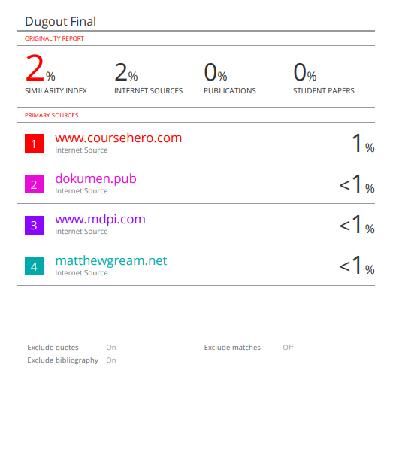

**TURNITIN AI REPORT**

